Name : Nischal Katara

Reg n.o : 21BCE10575

University : VIT Bhopal

**Project : Word Cloud Using Python**

**Enabling notebook extension fileupload/extension**

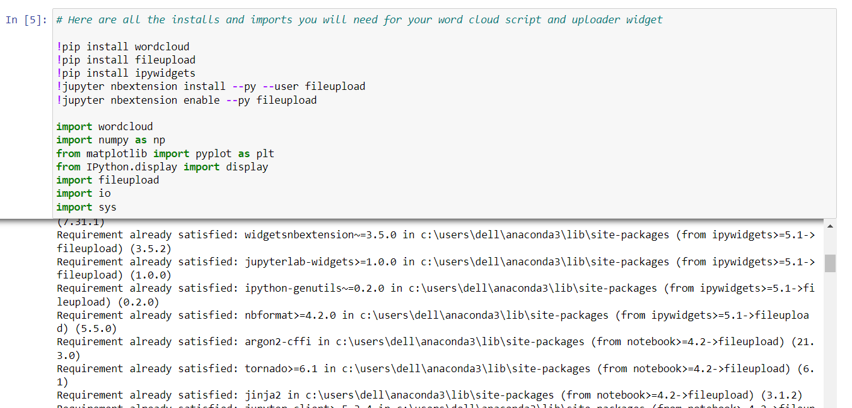

This project, I have created a "word cloud" from a text by writing a script.

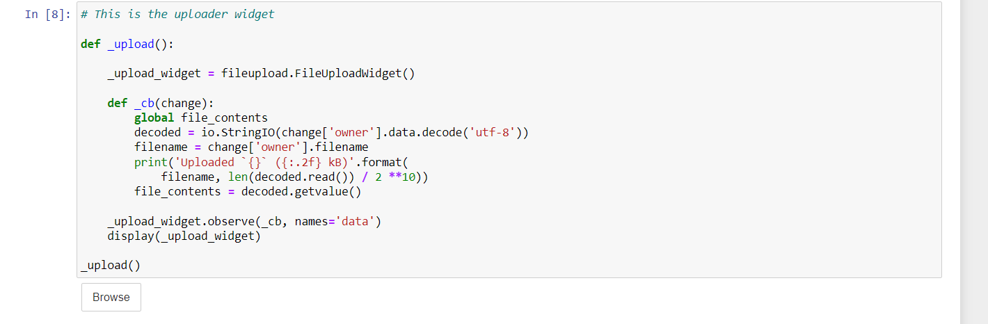

**FileUploadWidget(label='Browse', _dom_classes=('widget_item', 'btn-group'))**

The uploader widget saved the contents of your uploaded file into a string object named *file_contents* that your word cloud script can process.

A function in the cell below that iterates through the words in *file_contents*, removes punctuation, and counts the frequency of each word. Oh, and be sure to make it ignore word case, words that do not contain all alphabets and boring words like "and" or "the".

Then, generate_from_frequencies function to generate your very own word cloud!

This script needs to process the text, remove punctuation, ignore case and words that do not contain all alphabets, count the frequencies, and ignore uninteresting or irrelevant words.

A dictionary is the output of the calculate_frequencies function.

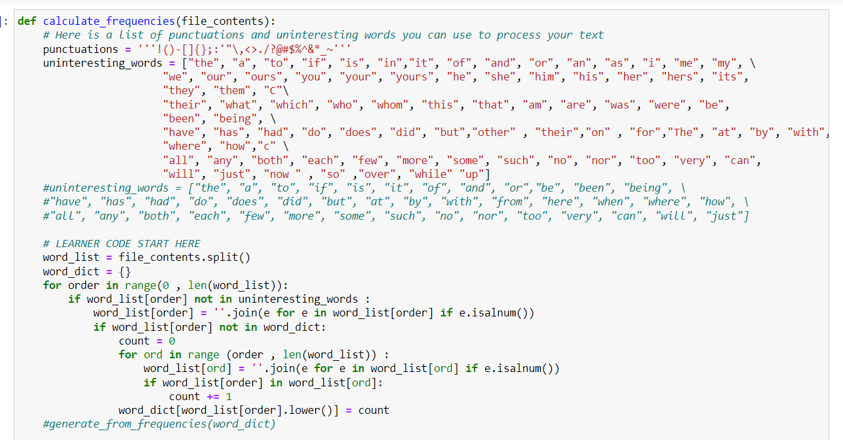

The word cloud module will then generate the image from your dictionary.

